AML Transaction & Fraud Analysis
Business Insight Report
Dashboard-based review of transaction activity, fraud classification and AML alerts
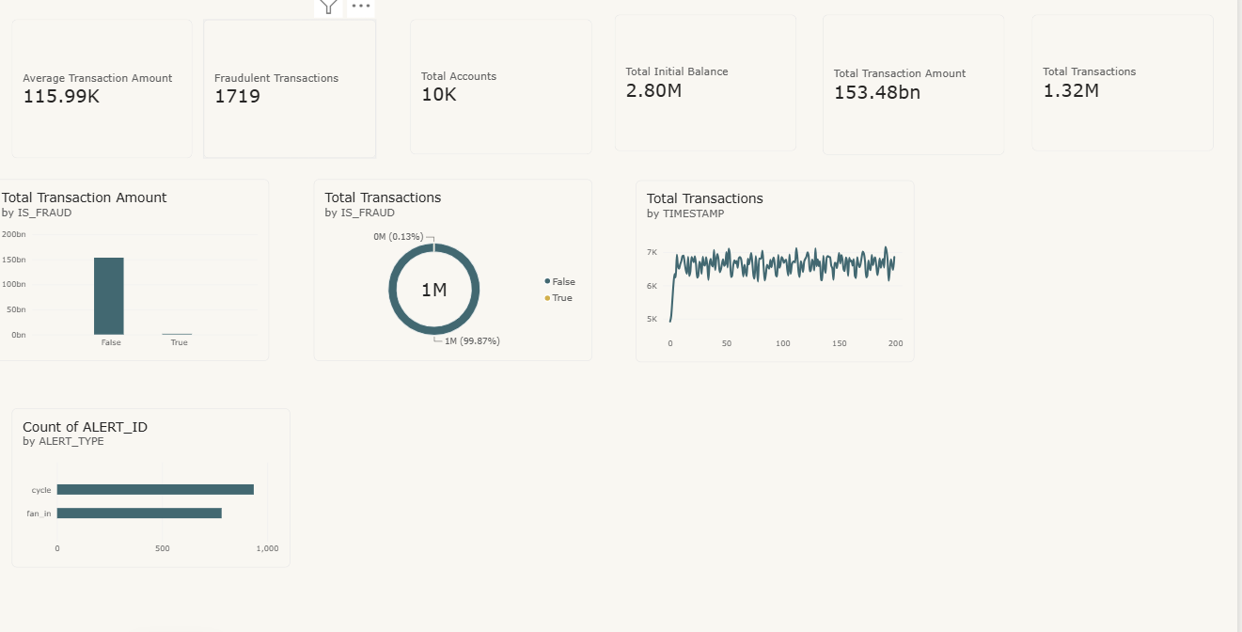The dashboard presents AML transaction activity and fraud-status classifications through KPI cards, charts, alert-type summaries and interactive filters. It supports review of potentially suspicious patterns and helps investigators prioritize activity for further assessment; it does not independently establish illicit conduct.
2. Overview of the AML Dataset
The dataset is used to examine transaction volume and value, time-based activity, fraud classifications and alert patterns. The purpose is to support risk-based review, identify activity that may warrant further investigation, and provide a concise view of operational indicators. Key fields include:
IS_FRAUD, TIMESTAMP, ALERT_ID, ALERT_TYPE. Their definitions, completeness and coding should be validated against the data dictionary and source system.
3. KPI Interpretation
KPI | Dashboard Value | Interpretation
Fraudulent Transactions | 1,719 | Transactions classified with the fraud indicator; classification requires review.
Total Transaction Amount | 153.48 billion | Aggregate transaction value shown; currency and aggregation basis should be confirmed.
Total Transactions | 1.32 million | Indicates a large volume of records/transactions in the dashboard scope.
Total Accounts | 10,000 | Accounts represented in the dashboard; confirm whether distinct account IDs are counted.
Average Transaction Amount | 115.99K | Average value displayed; verify currency, denominator and treatment of missing/duplicate records.
Overall, the KPIs indicate substantial transaction throughput and value, while a comparatively small number of transactions are classified as fraudulent. These measures are screening indicators and should be interpreted with the dashboard’s filters and aggregation logic.
Note: KPI values are based on the supplied screenshot. The underlying calculations and aggregation settings should be verified before using them for formal reporting.
4. Fraud Status Analysis
The pie chart using IS_FRAUD shows approximately 99.87% classified as False and 0.13% classified as True. The bar chart showing total amount by fraud status provides a value-based comparison between the two classifications; the displayed totals should be checked for consistency with the transaction-level data.
Insight: A low proportion of records classified as fraudulent does not imply low risk. High-value or connected activity may still merit review, and the classification should not be treated as a final determination.
5. Transaction Activity Analysis
The line chart by TIMESTAMP shows an initial increase in activity, followed by fluctuations around approximately 6,000–7,000. The pattern may reflect changes in transaction volume over time; the time interval, aggregation method and missing periods should be confirmed.
Insight: Time-based analysis can help identify unusual spikes, repeated patterns or activity outside expected operating levels.
6. Alert Analysis
The horizontal bar chart indicates approximately 930 Cycle alerts and 780 Fan-in alerts. A cycle pattern describes funds moving through a sequence of accounts, potentially returning to an earlier point. Fan-in describes funds from multiple sources converging into a single account. These patterns can have legitimate explanations and should be assessed in context.
Insight: Both alert types may require investigation, but an alert is not automatic proof of fraud or money laundering.
7. Filter-Based Analysis
The dashboard provides two filters: ALERT_TYPE (Cycle and Fan-in) and IS_FRAUD (True/False). These controls allow focused comparison of alert categories and fraud-status classifications. Confirm that each filter updates all intended KPI cards and charts consistently, and document the selected filter state when capturing or reporting results.
8. Key AML Insights
Fraud-classified transactions represent a small share of the overall transaction population shown.
The dashboard reflects a large transaction volume, increasing the importance of scalable monitoring.
The aggregate transaction value is significant and warrants careful validation and risk-based review.
Cycle alerts appear more frequent than Fan-in alerts in the displayed summary.
Transaction activity fluctuates over time; deviations from expected patterns may warrant examination.
Interactive filters support more targeted investigation and comparison across classifications.
Source data, definitions, filters and calculation settings require further verification before formal conclusions.
9. Recommendations
Strengthen monitoring rules using validated risk indicators and documented thresholds.
Investigate high-priority alerts by reviewing transaction chains, counterparties, context and supporting records.
Monitor activity continuously for material deviations from established customer or account profiles.
Improve fraud detection through periodic testing, model/rule validation and feedback from case outcomes.
Use risk-based investigation to prioritize unusual, high-value, repeated or interconnected activity.
Improve dashboard accuracy by validating measures, distinct counts, time grains, currency and filter interactions.
Maintain proper records of alert rationale, review steps, evidence, decisions and escalation outcomes.
Review false positives regularly to refine rules without weakening appropriate controls.
10. Conclusion
The dashboard provides a concise view of AML-related transaction activity, fraud-status classifications and alert patterns. The displayed indicators suggest high transaction throughput, significant aggregate value, a low proportion of fraud-classified records and a greater count of Cycle than Fan-in alerts. These observations are preliminary and depend on the data and dashboard configuration.
KPI cards summarize scale and value, while the pie chart, bar chart, line chart and horizontal bar chart help compare classifications, observe activity over time and prioritize alert categories. Filters can support focused review when their interactions and aggregation behavior are confirmed.
The screenshot-based KPI values and underlying calculations must be verified before formal reporting or operational use. Dashboard alerts and classifications are indicators for investigation, not conclusive proof of money laundering or fraud. Transactions and related evidence must be reviewed before any

